ATEC 3353: Game Studies

Electronic Article Databases (Journal Article Searching & More)
The library owns nearly 200 databases covering a wide variety of topics found in journals, magazines, newspapers, transactions, and conference proceedings, and dissertations to boot. Below are suggestions for databases that focus on game studies, including business and economics, game design and social studies. Access them from the library home page (www.utdallas.edu/library) under “Find Articles & Databases.”

- Academic Search Complete – [1865-present] an easy-to-use, multi-subject database with access to information from over 12,000 publications, over half of which are peer-reviewed and even more are available in full text. ASC does not have any particular subject focus, but it is a good place to start research or to look to for additional research materials. A good source for news, current events, and scholarly research alike.
- ACM Digital Library - A full-text database containing the full text of articles from the Association of Computing Machinery as far back as 1954. These include journals, magazines, transactions, proceedings, newsletters, publications by affiliated organizations and special interest groups (SIGs). You will find plenty of analysis of gaming and game theory, e.g., MMOs, online gaming and how games influence player behavior. The default setting includes all ACM publications (full text), but you can expand your search to include publishers outside of ACM through the ACM Guide to Computing Literature. For non-ACM publishers, you will need to check for their publications in Discover -> Library Catalog to determine whether the library has access to their full-text content.
- Business Source Complete [1886-present] accesses information and selected full text of articles from over 1,200 business and economics journals. Use this database for studying the business and economics of gaming and the gaming industry.
- Communication and Mass Media Complete – [1960s-present] the premier database for researching over 740 journals in the fields of mass/digital media, communication, and related disciplines. An excellent tool for locating recent scholarship on gaming studies, especially from the social science perspective.
- Computer Science Powersearch bundles Academic Search Complete, INSPEC, Computer Source, and Internet and Personal Computing Abstracts into a single search engine. CSP covers lay and scholarly literature from multiple disciplines, concentrating mainly on the areas of technology and game studies. Where full text is not clearly available, use the Get It! button to determine whether the library has access to a paper copy or an electronic copy through another (outside) publisher.
- IEEE Xplore is ideal for conducting research in the field of electronics, electrical engineering, telecommunications, and related sub-disciplines. It provides access to IEEE and IEE transactions, journals, magazines, conference proceedings, as well as current IEEE standards. Full text extends back to 1988 for all titles, with select titles going back to first issues (late-1800s and beyond).
- ScienceDirect [1970s-present] provides full-text access to over 2,000 scholarly and peer-reviewed journals from Elsevier Science, including hundreds of book series, handbooks and reference works. Journals cover a broad range of disciplines, but many are ideal for gaming studies in the realms of psychology, child development, health effects, gender studies, and more. NOTE: only full-text content to which the library subscribes will be available.
- SCOPUS [1966-present] is one of the largest article databases and covers the scientific, technical, medical, and social science literature - indexes over 19,500 peer-reviewed journal titles from over 5,000 publishers. SCOPUS links to full text when available.
- Web of Knowledge [1898-current] is the most comprehensive index in the humanities and science. It also shows how many times an article and/or an author has been cited since publication. Web of Knowledge, the online version of the Citation Indexes in paper, allows searching across multiple disciplines: the Science Citation Index, the Social Sciences Citation Index, and the Arts and Humanities Citation Index.
- WorldCat is a catalog providing information on millions of books, newspapers, maps, periodicals, government documents, etc. It is one of the most important resources for determining which library owns a particular work.
Electronic Journal Collections:
www.utdallas.edu/library/resources/journals.html
The following are collections of scientific journals available online. Each collection is searchable by keyword or journal title browse. These resources provide yet another avenue to access academic journal articles on your topic (gaming, game theory, etc.). Most but not all full text will be available, depending on the library's subscription.

Elsevier’s ScienceDirect Springer LINK
Nature Publishing Wiley Interscience (AKA Wiley Online Library
Cambridge Journals Online Project Muse

General Tips for Article Database Searching

- When possible, use the “Advanced Search” screen. The Advanced Search screen should give you all the options to refine and perfect your search, e.g., multiple search blanks that can be combined using AND, OR, or NOT; limiting to article title, author, or subject term; limiting to scholarly/peer-reviewed journals only; and more. When you stick to the single search blank from the Basic Search, you are missing all of the best and most powerful search options.
- Need help selecting terms? Try the database Thesaurus or Subject Terms. One place where possessing a good vocabulary really helps is with database and online searching. However, if you are struggling to find the right words for a topic, see if the database has a thesaurus (sometimes labeled “Subjects” or “Subject Terms”). The name you may have for a concept may not be the same as the one used by the database’s indexers. A search of the official subject terms or thesaurus will help you find the right words to search.
- The first search is almost never perfect. Skim abstracts of articles, find new terms to add, and reiterate, reiterate, reiterate your search. Sometimes you may find too many entries on a topic. In that case, skim the abstracts (article summaries) of the first couple of dozen or so articles, look for terms that continuously reappear or jump out at you, and then resubmit your search with the new terms you have found. Be willing to exercise this technique more than once. Each new iteration of your search and each new term you add or change will assist in reducing the number of hits returned while helping to focus the search on more relevant articles.
- I’m not finding anything. What do I do? Conversely, if you are getting too few results with a search, skim the abstracts of the articles that are returned and see if you can reword your search. You may have to scrap your original search completely and try it again using an entirely different vocabulary. See above about using the database’s thesaurus or subject term directory for help. Also, the problem could be that you are using too many terms. Most databases will “AND” all the terms typed into a single line together in the search. In other words, databases will require that all the terms typed in a single line be present in each article searched (term1 term2 term3 … = term1 AND term2 AND term3 AND …). Thus, removing those terms which are not absolutely necessary to your search can mean the difference between no hits and many hits.
Lastly, see if the database has an “All Text” search or a “search within the full text of the articles” feature. Many databases do not automatically search the full text of articles and must be instructed by you to do so.
- Use wildcards, truncation keys, and “quotation marks” for added precision and flexibility. Almost every database supports the use of wildcard and truncation keys. A wildcard, typically “?”, is used to replace a single character in a word. It can be used anywhere in a term, even multiple times in a word, but it is normally used to account for singulars and plurals of a term, e.g., wom?n for women and woman. A truncation key, typically “*”, is similar to a wildcard, except that it will be found only at the end of a term and can replace one or more characters, e.g., comput* for computer, computing, computation, etc. See the database’s “Help” screen for more info and which characters it uses for wildcards and truncation keys.
Lastly, a good rule of thumb is to surround a search phrase in quotation marks, e.g., “no child left behind”. If you do not want the database to look for the terms separately and in any order whatsoever, quotation marks “ “ will instruct it to keep the phrase intact and return matches only for the exact phrase. In some databases, an “exact phrase search” option may be an option in part of the Advanced Search, in which case the quotation marks are unnecessary.

Journal Searching and Finding Articles from Citations

“I found a great article, but where’s the full text?” Using Your Article Citation to Find the Full Text
Occasionally, you will run into database entries that contain information (the citation and perhaps a brief summary, called the abstract) on articles you would like to read, but there is no obvious indicator of full-text content. The brief guide below will instruct you on how to find the full text at the library.

Take a look at this example of a journal citation found in the database Computer Science POWERSEARCH:
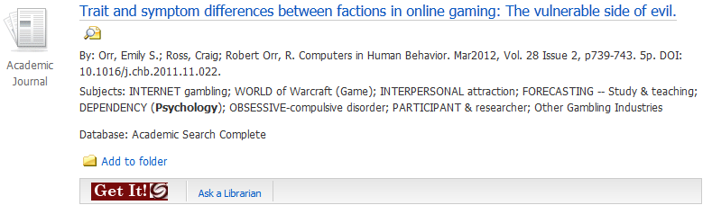

Notice that there is no link for full text, only the dark red “Get It!” box. Follow these steps to get the article:
- You may click on the “Get It!” box to attempt to access online content. While this method works sometimes, it is not failsafe. It is not uncommon for “Get It!” to fail to connect to online content when the library does in fact have access to that content. You should keep in mind that “Get It!” will not tell you if the library has access to the article in paper. While “Get It!” is meant to be a time-saving device, do not rely on it as the final answer on whether the library has access to a particular article. If you don’t get the full text, go to the next step. If you only have a journal/periodical title in hand and want to access its articles, also go to the next step.

- Another method to find out if the library has full-text access to an article is to start with Discover -> Books, Articles & More. You may search by the article title using this method, although keep in mind that not every article the library has electronically will be listed here. In this case with the article, “Trait and symptom differences between factions in online gaming: The vulnerable side of evil,” we failed to get a match:
Search by article title (with quotation marks “ “): “Trait and symptom differences between factions in online gaming: The vulnerable side of evil”.
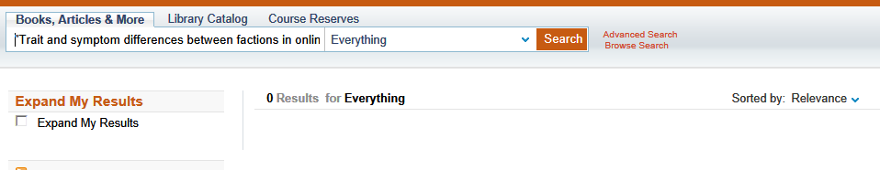
Sadly, no matches.
Now we must resort to Discover -> Library Catalog: Advanced Search, limit by Material Type: Journals, and search by the journal title, in this case, Computers in Human Behavior:
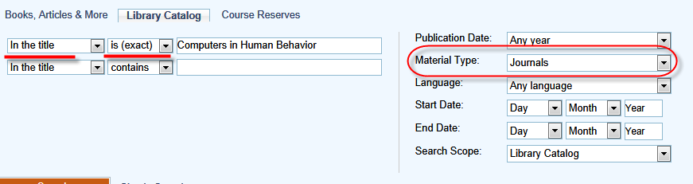
In this example, you should get one match for the electronic version of Computers in Human Behavior, available from ScienceDirect Complete back to 1995 (vol. 11, issue 1), which easily covers the date of the article we want:
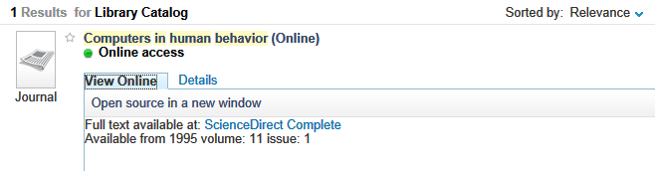
Note that by limiting to Material Type: Journals and telling the catalog In the title … is (exact), you will be searching the catalog for newspapers, magazines, and journals only and excluding any books which may have the same title. These limiters can be very helpful when searching for a common journal or magazine title such as Time, Science, Nature, or People. Another good rule of thumb is not to use abbreviated titles for your journals (spell out the title completely) and avoid, for example, shorthand such as “&” for “and”.
If a journal/magazine/newspaper is available electronically, there should be a View Online tab you can use to access it online, sometimes by more than one publisher, and for multiples dates. If it is available in other formats (paper or microform), you will see a Locations tab as in this example for the New York Times:
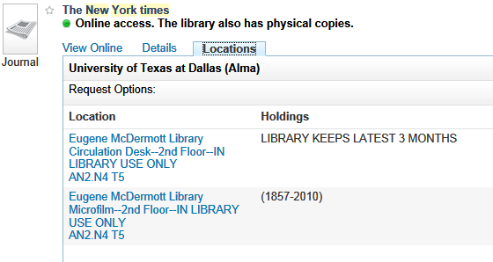

For any location other than electronic, you must have the call number to find the publication on the shelf. Note: Journals, newspapers and magazines in the Journals section are not shelved by title, but by call number.
- If you have tried the catalog and your search has yielded no results (remember, the “Get It!” button alone does not search for everything the library has), you have the option of requesting the article via Interlibrary Loan (ILL) (http://www.utdallas.edu/library/services/ill/index.html - find the link for it under “Services and Tools” on the library homepage). You will be asked for all the information listed in the citation in order to facilitate the fastest processing of your request. In one to three business days, you will be notified by your UT Dallas e-mail that your article is ready to retrieve via your ILL account. ILL is free and fast, but it can only be used to request items the library does not already own. Be sure to check the catalog before using this service!
- Lastly, I strongly encourage you to ask for assistance at the Reference Desk if you are still encountering any problems utilizing our resources. Find our contact information, including links to e-mail and IM reference, by going to the Ask-a-Librarian icon located throughout the library’s site. Remember, if you don’t ask for help, we can’t help you!

5 Criteria for Evaluating Web Sites (Applicable to Any Media or Information Source):

- Audience – To whom is the site directed – children, adults, students; a certain ethnicity, gender or political affiliation? Is it understandable by the layman, or is it highly technical, requiring specialized knowledge?
- Authority – Is the author of the site listed? Can you determine his/her expertise? Is contact information given – phone number, address, e-mail? With what organization is he/she associated?
- Bias - Do the language, tone, or treatment of its subject give the site a particular slant or bias? Is the site objective? Is it designed to sway opinion? Determining organizational affiliation can often help gauge bias.
- Currency – Is the site up-to-date with working links? Are dates given for when it was created and last updated? Is the topic current?
- Scope – Is the site an in-depth study of the topic going several pages deep, or is it a superficial, single-page look at the subject? Are statistics and sources referenced properly cited? Does the site offer unique information not found anywhere else, e.g., print sources?

Peer-Reviewed or Scholarly Journals vs. Magazines: What’s the difference?

One of the main reasons researchers turn to databases is to have the ability to search for peer-reviewed articles. The following briefly explains how peer-reviewed articles differ from popular articles.

Popular Magazines (Time, People, etc.)  Intended for a general audience.  Articles written by journalists who may or may not have special training in what they are writing about.  Articles do not have footnotes.  For Profit.  Not Peer-reviewed. | Scholarly/Peer Reviewed Journals (JAMA, etc.)  Intended for an audience with knowledge in the field.  Articles are written by scholars, whose names are listed along with credentials.  Articles are footnoted and list sources used.  Usually not for profit.  Peer-reviewed.

How do I find articles from Peer-Reviewed Journals?
Use a scholarly database rather than a general database (e.g., MEDLINE vs. Newspaper Abstracts). In many of the databases, you can limit to scholarly/peer-reviewed journals only.

Is my journal peer-reviewed?
The Ulrichsweb.com database is an online periodical directory. Search for your journal by title or ISSN and find out if it is peer-reviewed (aka academic, scholarly, or refereed) or not.

“What do I do if the library doesn’t have what I need?” Interlibrary Loan and TexShare

Interlibrary Loan (ILL)
If UTD does not own the periodical or book you need, you may submit an Interlibrary Loan (ILL) request at www.utdallas.edu/library/services/ill.htm (or look under “Services” on the library home page). The library will try to obtain your requested item, usually within a week (one to three business days for articles) and at no cost to you. See the instructions on “Journal Searching and Finding Articles from Citations” to find out more on when ILL requests are warranted.

TexShare
www.utdallas.edu/library/help/forms/texshare.htm In an emergency or a situation in which ILL cannot fulfill your request on time, TexShare can be a lifesaver. With a TexShare card, you can check out materials from participating libraries across the entire state of Texas, which include most public, community college, and university libraries. Follow the link above to apply for the card and read about terms and restrictions. To find out which libraries in the area own an item you need, go to the WorldCat database under “Find Articles & Databases” on the library site or access www.worldcat.org/.

Writing Resources

Citation Style Guides
The most popular, latest edition citation style guides (MLA, APA, Chicago/Turabian) can be found behind the Reference Desk (2nd floor). Other copies may be available in the Main Stacks (4th floor). Check the library catalog for availability http://library.utdallas.edu.

Online Citation Resources

- Go to the Useful Web Sites on the library’s homepage under Resources and visit the “Citation & Style Manuals” category (www.utdallas.edu/library/resources/hot.htm#citations). There you will find numerous sites to assist you with the APA, MLA, Chicago/Turabian and other paper formats.
- RefWorks Citation Manager – manage citations and automatically generate works cited for your papers. Available from the library’s homepage and at www.utdallas.edu/library/resources/refworks/index.htm.

In-Person Writing and Citing Assistance

- Writing Center, Student Success Center (formerly GEMS Center) –
www.utdallas.edu/GEMS/writing/index.html located in MC 1.206, 972-883-6707. The lab can proofread, spell-check, and citation-check your paper. Although walk-ins are welcome, students are strongly encouraged to make an appointment in advance.

Need More Help?

Try the ATEC 3353 (“game studies”) research guide (http://libguides.utdallas.edu/atec3353) for advice on where to start looking for books, journal articles and scholarly studies on gaming and game studies. It contains links to useful websites for paper preparation (writing & citing), too. Lastly, feel free to contact me as the need arises. My contact info is listed below:

Click for Ask a Librarian assistance: call, e-mail, IM, or text a librarian; or
Contact me, Matt Makowka, Reference Librarian, Engineering/EMAC/ATEC Liaison.
mattmm@utdallas.edu
972-883-6773
Access the companion site to this guide at http://libguides.utdallas.edu/atec3353

An Equal Opportunity/Affirmative Action University
P. O. Box 830643 Richardson, TX 75083-0643 972-883-2955
Fall 2013

